The following are instructions on how to load a DSP FILE to a Crown amplifier using System Architect.
Note: This is for an amplifier which has not been programmed before.
__________________________________________________________________________________________________
STEP1: Ensure the latest version of system architect (3.40) is loaded on your computer.
Download here: http://audioarchitect.harmanpro.com/en-US/audio-architect-system_architect
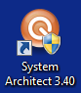
STEP2: Start System Architect.

STEP3: Copy venue file on your computer if not already there.

STEP4: Open venue file either from recent items location or location it’s copied on your computer.
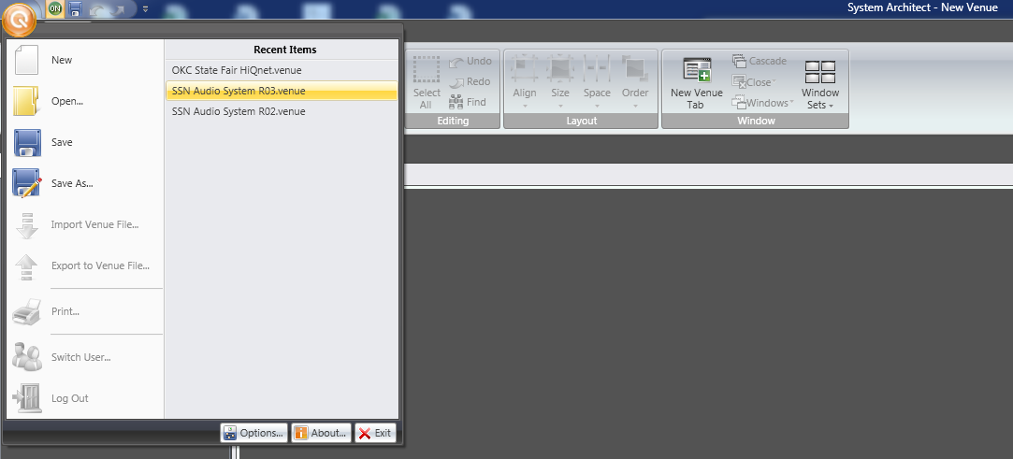

Home View Snapshot:
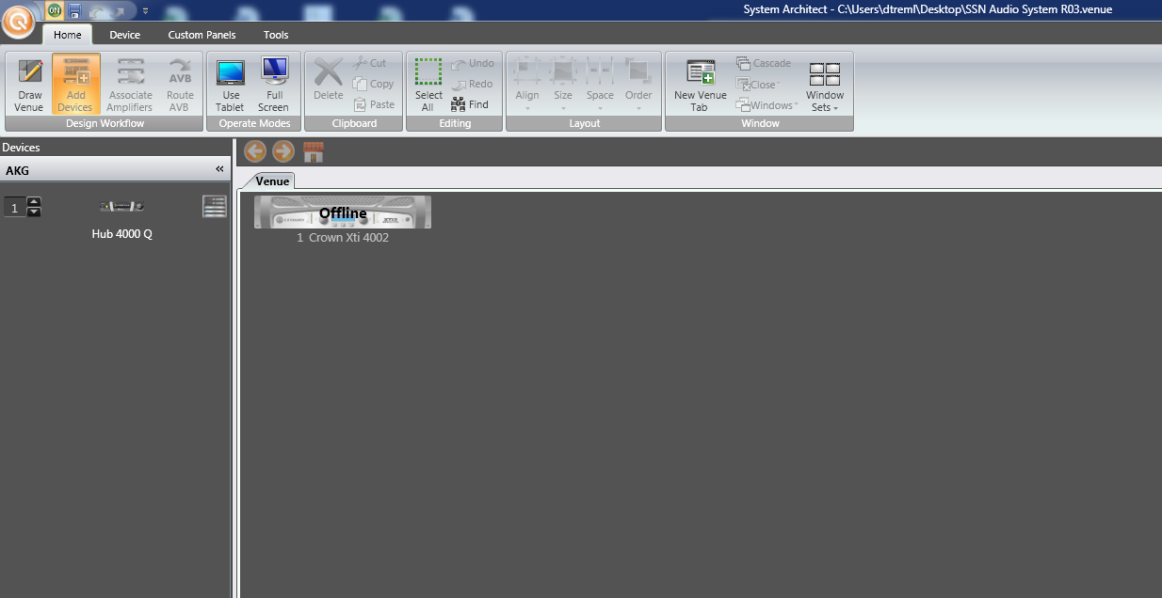
Device View Snapshot:
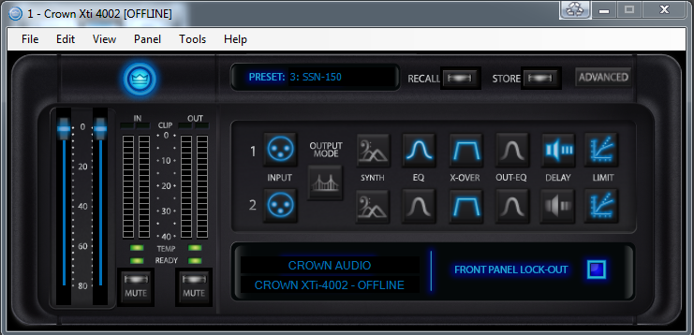

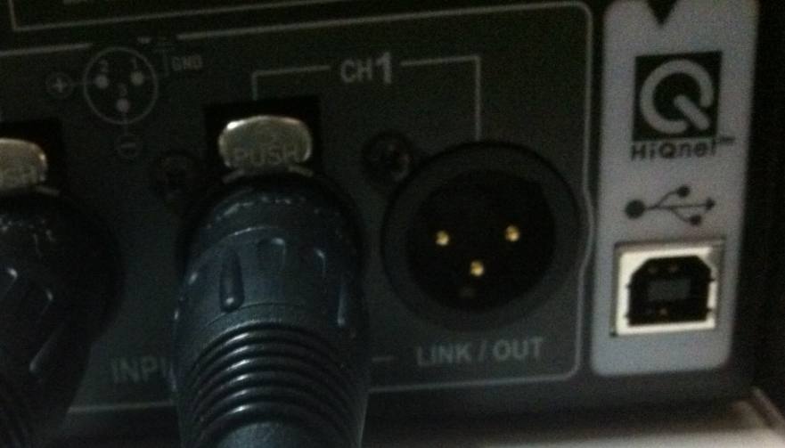
STEP5: Turn on amplifier and plug cable into HiQnet port. A “USB A to B” cable is required.

STEP6: Plug cable into open USB port on your computer.
STEP7: Send file to device (amplifier). 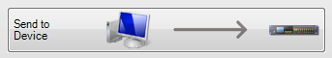 File will take a few moments to get pushed on your device.
STEP8: Double click the amplifier icon 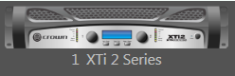 and load desired preset in amplifier by clicking the recall Icon 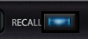 in the popup window.
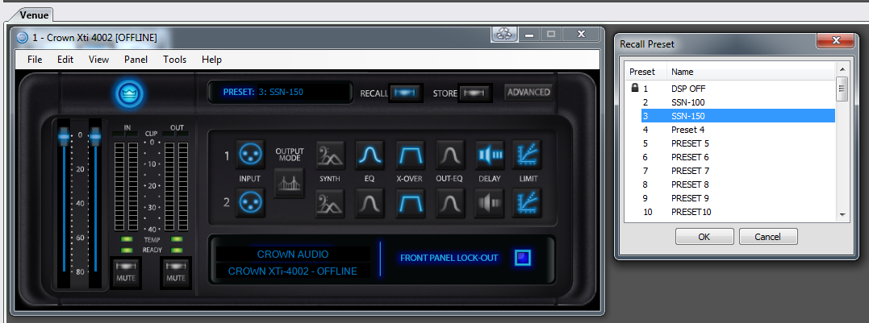

Preset 2 = “SSN-100” Standard Indoor Gym System without additional subwoofer.
Preset 3 = “SSN-150” Standard Indoor Gym System that includes additional subwoofer.

Front LCD screen on amplifier should indicate the preset file currently selected. Ensure that the correct file is displayed prior to shutting down.
LOCKOUT NOTE: The standard SSN-100/SSN-150 R03 venue file has the “Front Panel Lock-Out” checked within the software. If you need to Unlock the front panel to gain access to the controls, you need to connect to the system as shown above. You will be unable to unlock the front panel through the front button controls.
Daktronics suggests the front panel stay locked to eliminate unauthorized use. The rotary knobs always operate. To lock the front panel without being in the software hold down “Prev” and “Next” until the screen says “Locked”. Follow same operation for “Unlock”.

